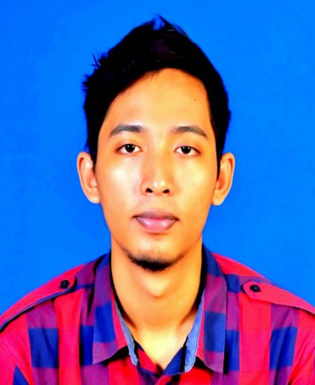

***PERSONAL DIRECTORY***

Name : Wan Izzatfahmi Bin Wan Jaafar

Address : Lot 2254, Kg Cherang Meranti

17010 Pasir Mas, Kelantan

Telephone : 09-7976852 (Home)

014-5201572/010-9199068 (Hp)

Email : [wanizatfahmi@gmail.com](mailto:wanizatfahmi@gmail.com)

***OBJECTIVE***

-To obtain employment opportunity and gain challenging career in an organization where I can utilize to the fullest skills I have acquired in my area of study while help a successful company expand further and help myself grow further professionally in my career.

***PERSONAL DATA***

Nationality : Malaysian

Date of Birth : 2 January 1993

Place of Birth : Pasir Mas, Kelantan

I.C Number : 930102-03-5855

Age : 23 years

Gender : Male

Marital Status : Single

Religion : Islam

Race : Malay

Health : Excellent

Hobbies : Football and traveling

Personality : **-**Strong interpersonal and communication skills

-Resourceful, energetic and competent

-Fast learner and passionate on new challenge

-High-level commitment and high self-motivation

-Ability in leadership skills and work well as team member or independently

***ACADEMIC QUALIFICATION***

* 2011-2014 Diploma in Mechanical Engineering

Politeknik Kota Bharu

CGPA : 2.93

* 2010 Sek. Men. Teknik Pasir Mas

SPM (5A 2B 1C)

***WORK EXPERIENCE***

* 2014 **MultiWireless Sdn.Bhd**

Drive Test Engineer

-Radio Network Drive Testing and analysis data GSM 900/1800, WCDMA, HSDPA, UMTS, GPRS, EDGE, and WiMAX

-High level troubleshooting of the drive test, network quality problem, especially within layer 3 and signalling

- Performing RF Technical site survey, drive test site and cluster level analysis

-Conduct additional IP data data testing and results documentations

* 2012-2013 **Jabatan Pengairan & Saliran Negeri Kelantan**

**Bahagian Perkhidmatan Mekanikal dan Elektrikal (JPS BPME)**

Internship

-Maintenance of diesel and hydraulic pumps engine and the components.

-Installing the pumps engine for agricultural irrigation and flood control.

-Control the stability of pumps engine after the installation.

-Assemble and disassemble a few types of pump’s components

***PROFESSIONAL QUALIFICATION AND AWARDS***

* 2015 FIRST AIDER CERTIFICATED
* 2014 SMAW (CS) PLATE 3G WELDER CERTIFICATE
* 2010 UBSJ CERTIFICATE (UBS Computerised Accounting)

***TECHNICAL SKILL***

* Familiar in Gnex Probe 3.5, Microsoft Office, Microsoft Excel, Microsoft PowerPoint, Autocad and Mapinfo
* Familiar in Arc Welding SMAW (3G), Tungsten Inert Gas (TIG), Metal Inert Gas (MIG)
* Experinced in performing RF Technical site survey
* Experinced in perform drive test site and cluster level analysis

***EXTRA CURRICULAR ACTIVITIES***

* 2015 -Basic First Aid Course (CPR NCORT GUIDELINE 2011)
* 2013- 2014 -Program Industry Centre of Excellence(ICoE)- Kluster Automotif by

Automotif Engineering Centre(AEC) & University Malaysia Pahang

-Oil & Gas Technical Communication & Softskills Induction Course by UTM

-Oil & Gas Safety Passport Course (OGSP) by NIOSH

-SMAW (CS) Plate 3G Welder Course by CIDB Malaysia

-Workshop Safety and Management by FREEWILL AUTO SDN BHD

* 2010 - Constable of Polis Diraja Malaysia – Represent School

***COMUNICATION SKILL AND INTERPERSONAL SKILLS***

* Good communication skills, fluently in English and Bahasa Malaysia (verbally and writing), computer literate, team player, self-independent, self-initiative, responsible and proactive.
* Good interpersonal skills in dealing with other

***AVAILABILITY***

* Can start work immediately
* Valid driving license

***REFERENCE***

* Mr.Karthik

Project Manager

Multiwireless Sdn.Bhd

30A & 30B, Jalan President U1/F, Accentra Glenmarie

40150 Shah Alam.

<Tel:03-55695929> (Office)

017-3051550 (Hp)

* Mr.Azihan Bin Kamarudin

Lecturer of Department of Mechanical Engineering

Politeknik Kota Bharu, KM 24 Kok Lanas

16450 Ketereh,

Kelantan.

Tel :019-9872540 (Hp)